Framework for SDN Confidence Assessment as a Service (CAaaS)

Joshua Alcorn
Computer Science Department
University of Colorado at Colorado Springs
Colorado Springs, CO 80918
jalcorn@uccs.edu

Scott Melton
Computer Science Department
University of Colorado at Colorado Springs
Colorado Springs, CO 80918
smelton2@uccs.edu

C. Edward Chow
Computer Science Department
University of Colorado at Colorado Springs
Colorado Springs, CO 80918
cchow@uccs.edu

ABSTRACT
Never before have concerns for personal privacy and information security been as prominent as they are today. Mobile devices, the Cloud, and the Internet of Things are becoming a part of everyday life. This is driving the need for added security measures to prevent unauthorized access of data that has left the user’s control. Software Defined Networks (SDN) provide a network awareness not available in traditional networking. SDN provides statistics data as well as operational configuration data in the environment. By accumulating a time series data repository we can assess the environment to establish known behavior and security patterns. We propose a framework that utilizes this repository to assess a relative security confidence level based on these patterns. For this paper, we address several SDN network metrics and their impact on security confidence levels. For a representative implementation on how SDN metrics can be used to independently assess a network we focus on route trace, verification and validation of data transfer before, during and after the transmission of sensitive data.

Keywords
Software-Defined Networking (SDN), OpenFlow, Security Metrics, Traceroute.

INTRODUCTION
True “trust-no-one” security is becoming increasingly difficult to implement and a burden to use. As a result, we are left trusting third parties with certificates, keys, and verification. At the same time the resources available to malicious attackers to intercept data, conduct brute force attacks and exploit man-in-middle vulnerabilities is growing rapidly. SDN provides the means to create data resilience outside of the user’s control and reduce the chances of accidental data spillage. Our approach will also help remove some of the security burden from the user, as the network is providing enhanced validation and authentication.
Today if you want to send a secure message from one person to another, the sender, Bob, first encrypts the message. Then Bob binds the message in an authenticated wrapper. Next Bob sends the message through/over the network to the receiver, Dave. Dave first verifies the authenticity of the message (is it really from Bob or is it tampered malware?). Once verified, Dave then decrypts the message (this may also include Dave verifying his identity to an authentication server – prior to receiving the decryption key).

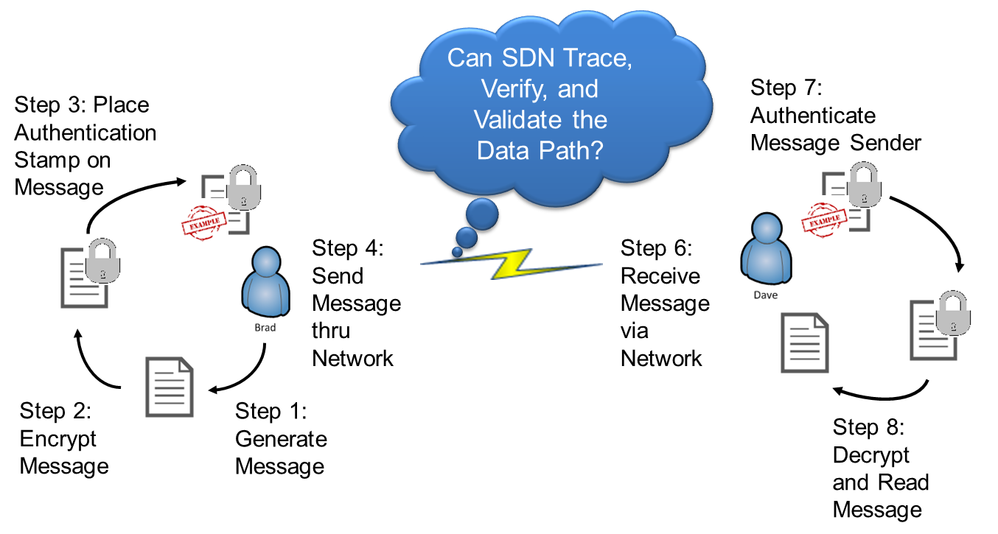
Figure 1. Traditional Network Secure Access Approach
At no point in the scenario above, see Figure 1, has any analysis of the transport medium been assessed. We propose utilizing the power of SDN to do exactly this – verify, validate, and assess the data path.
We intend to design and implement a framework for SDN security confidence analysis. In order to enhance traditional analysis, we utilize SDN in two key areas; route and destination verification and switch metrics analysis. Referring to Figure 2, this framework will allow SDN authentication applications to validate and verify the routing and destination of data as well as assess the network devices for unexpected behavior (i.e. data compromise, man-in the middle attacks, etc.) This framework provides a confidence analysis of network security elements.
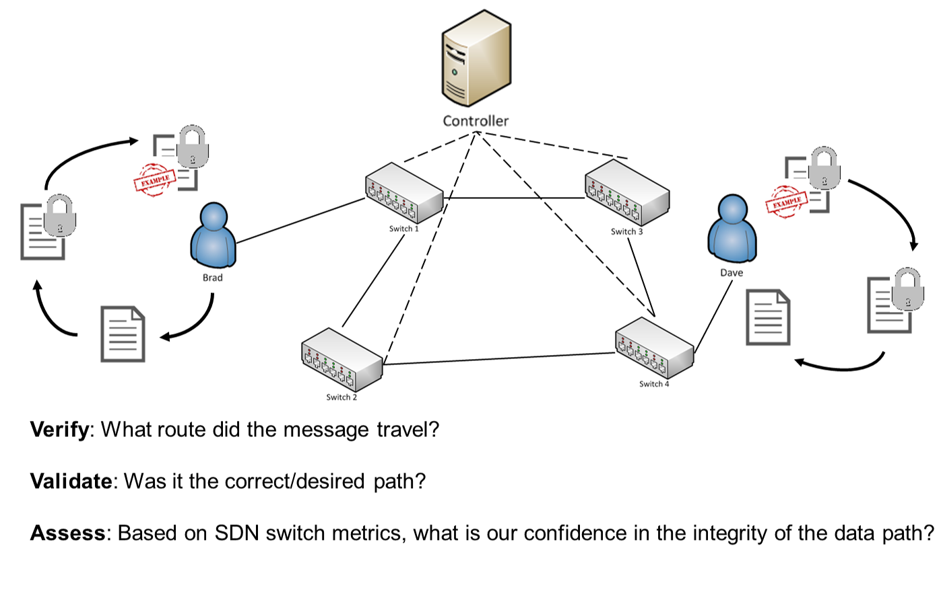
Figure 2. Framework for SDN Confidence Assessment
Some areas of this paper identify particular techniques for measuring and quantifying confidence factors such as the actual route and destination of a data flow. Other areas propose guidelines or possible methods for establishing other confidence factors. Our overall approach is to establish a generalized framework within an SDN network and in conjunction with traditional network analysis for the development of SDN confidence applications that authenticate, validate and verify different areas of security in the network.
Section 2 provides a review of existing related work. Section 3 covers a brief overview of SDN, highlighting the uniqueness of SDN compared to the traditional networking and defining the need for enhanced traffic security. Section 4 reviews our approach to improve proximity based secure access via a SDN confidence assessment approach. Section 5 is an explanation of the confidence analysis framework that we propose for this service. Section 6 is our SDN confidence evaluation methodology, experiments, and identified use cases, and Section 7 concludes the paper.

RELATED WORK

Pathlet Routing
A team from Berkeley researched a new protocol for tracing the data path. They offer a new scheme, pathlet routing, in which networks advertise fragments of end-to-end paths from which a source can assemble an end-to-end route. This technique does not focus on SDN or the potential benefits of network awareness/control [1].

Pathlet Tracer
NEC Labs developed Pathlet Tracer, a traceroute-like concept that provides a limited route step verification and path validation [2]. Currently this in in the theoretical phase; however, the concept of an SDN controller that generates a “codebook” of flow IDs and routing is an interesting approach.

SDN Traceroute
IBM researchers propose a tool, SDN Traceroute, which can query the current path taken by any packet through an SDN-enabled network [3]. The key to this approach is that the path is traced by using the actual forwarding mechanisms at each SDN-enabled device without changing the forwarding rules. Any tracer module must have a low overhead of network resources in order for it to be of any real-world utility.

ICING & Path Verification Mechanism
Using Path Verification Mechanism (PVM), ICING provides two mechanisms for policy enforcement, Path Consent and Path Compliance [4]. It offers a method determining if a packet followed an approved path; although their results indicate, ~93%, a very high cost to network operations. Furthermore this method involves modifying the packet header, which is an undesirable (and potentially dangerous) approach.

OVERVIEW OF SDN & BENEFITS

Understanding SDN
Gaining an understanding of the benefits and challenges of SDN/OpenFlow is essential to enhance the confidence that users have when sending sensitive traffic across the network. Regardless of the network topology or scale, the network hardware consists of three key components: application, control plane, and data plane. The control plane maintains information that can be used to change data used by the data plane. Maintaining this information requires handling complex signaling protocols. The data plane is a subsystem of a network node that receives and sends packets from an interface, processes them as required by the applicable protocol, and delivers, drops, or forwards them as appropriate, see Figure 3 below [5, 6]. The control plane is responsible for providing the routing logic to the data plane.
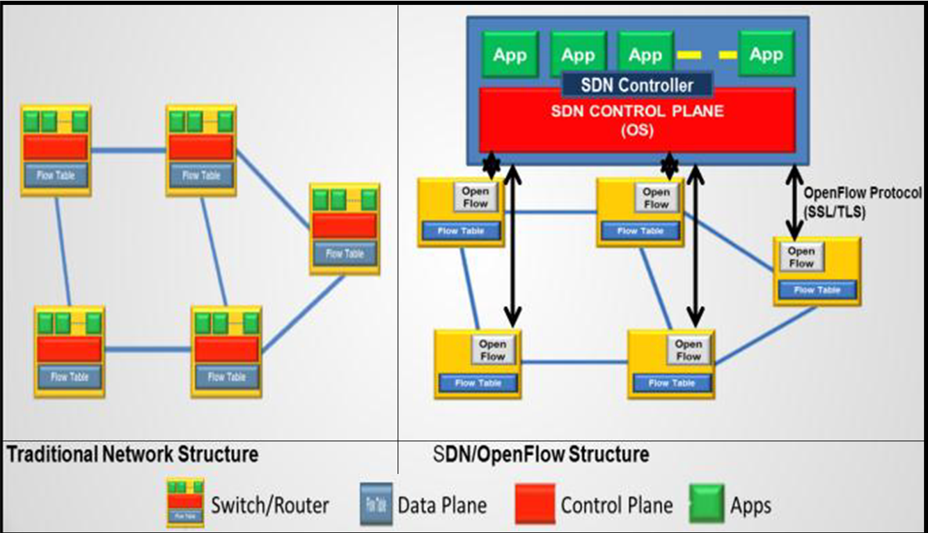
Figure 3. Traditional vs SDN Structure
With SDN, the data and control planes can be separated enabling more programmable and flexible networks, see Figure 3 above. One of the primary technologies behind SDN is the open source protocol - OpenFlow [7]. In additional to abstraction of the control plane, an additional TLS/SSL secure channel is established to support out of band communication directly between the controller and the switches.

Benefits of SDN for Security Applications

Better knowledge/control of complete data path
This is the ability to know the actual data path and therefore being able to discount everything not in the path. In traditional networks, every switch and router is an island and you rarely know the complete end-to-end path without tracing it hop by hop [8].

Abstraction of Control Plane
SDN can take configuration and control of how traffic flows through a network out of the diffused hands of the infrastructure and put it in the centralized hands of the network owner, individual users or individual applications. This may prove useful for load balancing, flow control and virtual networking in data centers, private clouds and campus LANs where devices are multiplying and straining network topologies like Spanning Tree, which can take tens of seconds to reconverge after a topology change [9].

‘Self’ Defending Network
SDN leverages telemetry and flow tables in the controllers “centrally” and then “dispatch” the necessary security response on an as-needed basis to the network location that needs it [13].

Separation of hardware and software development
It offers a horizontal architecture for networks to evolve separating the hardware platform from the applications [10].

Virtual Switch Support
Production-quality implementation of a distributed virtual multilayer switch is now available. They provide a switching stack for hardware virtualization environments. Examples of this include OpenvSwitch and Cisco Nexus 1000V [11, 12].

Flexibility
SDN creates flexibility in how the network can be used and operated. Users can write their own network services using standard development tools for their own unique environment and needs. For example a firewall application may need a high-performance, low-latency, low-complexity data exchange, while a monitoring application might only need to read flows as they pass [11]. The ability for SDN to dynamically “slice” the network traffic based upon protocol, payload, or addressing is very difficult in traditional networking.

Traditional Traffic Traceability & Switch Metric Limitations

The ability to independently verify and validate a network path is limited by the very architecture of traditional networks. This architecture puts the flow control decisions (how a packet is routed) into the switch fabric (forwarding plane). This allows routing protocols such as OSPF to dynamically change a data path in the middle of data transfer. To discover such changes, route tracing mechanisms must be present in every piece of hardware being monitored. Otherwise the route may change while the route is being verified. It can also change the path to include outside networks that would be previously unverifiable. Without complete monitoring coverage the volatility of network paths renders traceability and some switch metrics to a best guess effort [14].

Need for Traffic Traceability & Switch Metrics
Public and private networks alike depend on some of the same shared network infrastructure. Traffic isolation is key to the correct behavior of this infrastructure. For example, a business could be required by law to keep sensitive customer data isolated from other traffic. This data could also be restricted to what countries it resides in or travels through. Intelligence agencies restrict different levels of classified information from traveling across certain devices or network segments. Even at the host level datacenters must ensure that traffic does not flow across the devices of other customers. From a threat perspective, network route and destination verification is key to providing security against unauthorized access and compromised infrastructure. One compromised switch could route data across forbidden boundaries without the policy enforcement mechanisms knowledge. For these reasons, route and destination verification and validation are essential to network security.

SDN CONFIDENCE CONCEPT

Intersection with Proximity Based Secure Access
Working in conjunction with the Proximity Based Secure Access (PBSA) project, currently supported by Northrup Grumman, we are exploring an approach to enhance SDN security by providing a confidence assessment of the physical data transport using network metrics.
PBSA researchers are investigating an approach that uses encryption and geolocation to prevent unauthorized access to data. At the point where data decryption is attempted, multiple factors are evaluated before the encryption key is provided, such as geolocation, authentication with designated servers, IP address, hop limits, and time-to-live. If data is outside of its approved range, then it becomes undecryptable and may even self-destruct.

Overview of SDN Confidence Analysis
To enhance the multiple factors that PBSA employs to verify authorized access, we are examining the new networking paradigm - SDN. By separating the control plane from the data plane, SDN allows greater control and visibility into network state. We hope to capitalize on these benefits and provide, via a northbound API, a PSBA authentication service with a combined confidence assessment of not only the network medium (switches, routers, timing, etc.) but also a comparison with the physical data transport path.
Combining these two elements is not possible with traditional networking for several reasons: (1) traceroute is not a validation of the actual data path and is not in real-time using actual flow routes (2) proprietary switch/router hardware and software limit access and information sharing across the network fabric. The advent of SDN provides us with a framework for developing protocols to access network hardware and gather metrics like the actual network topology, latency between devices, lapse time, flow metrics and the physical device data. Assessing these data points alone can provide some increased confidence that sensitive data is reaching an authorized recipient; however, a near-real time trace of the actual data routing will add considerable validation of the data transport. We propose a method for providing multiple traceroute assessments with limited network overhead, which can then be compared with network metrics for a greater confidence assessment.
The overall goal of the SDN Confidence (and PBSA) is to ensure that data is accessed by the right person, in the right place, at the right time and delivered to a verifiable destination via the correct and verifiable network route. Our proposal of combining an analysis of network metrics and actual data flow can provide an increased level of confidence in proving this goal. Providing a service to access this analysis will allow not only PBSA implementations, but any verification tool to access this critical information. Currently we are working on a SDN controller agnostic confidence assessment as a service (CAaaS) that can be used by the PBSA and other projects.

SDN CONFIDENCE FRAMEWORK

Our confidence assessment approach has two parts. The first validates and verifies the network configuration for the data being transferred using different methods. Second, we use a large amount of information about the network, switch metrics like duration, elapsed time and network metrics like latency and total transmission time to establish a confidence level. This section identifies a Route Verification Method from the first part and several metrics and experimental values from the second.

Route Verification Approach
We propose a route verification technique that will limit network overhead and hopes to validate the path of the actual flow. The concept is to compare data from three flows: pre, actual, and post. Pre and Post segments will be small in nature, to limit overhead, but will provide necessary route and metrics for comparison with the actual message traffic. One example process for route verification is as follows:

Pre-Traffic
Once the source identifies a destination for traffic, the SDN Confidence service will begin action. First, a pre-traffic flow will be sent from the source to the destination in order to baseline actual route and device metric. A single pre-traffic packet will have very small overhead on the network and require limited time to execute.

Actual Traffic

Next, the actual traffic will flow. During the flow, we will employ a process similar to the method describe by IBM in the SDN Traceroute research [3]. The overhead of this approach should also be minimal considering the communications are between the switches and the controller which is a separate channel and the actual message traffic.

Post-Traffic
Lastly, a post-traffic flow will be sent from the source to the destination in order to provide a post transmission measurement of the network path and device metrics. Similar to the pre-traffic packet, this should have minimum impact on the networks overhead.

Current SDN/OpenFlow Device Metrics
The current OpenFlow protocol supports Meters (aka Metrics) collection - NOTE: Counters wrap with no notice. Durations are the amount of time that the Flow Entry has been installed on the switch. A brief sampling of what is available under OpenFlow 1.0 includes per flow duration and bytes received. OpenFlow 1.3 adds counters, packets received, and allows for the establishment of grouping [15].

Metrics for SDN CAaaS
To better highlight the metrics collected and how they may be analyzed, reference the example network topology in Figure 4 and assume the host A is sending a sensitive message to host C.

Route Verification
This is described above in greater details; however, utilizing the example network and scenario in Figure 4. We would accept the following:
UVariablesU: P = packet, F = flow, x, y, z = transmission number, Cr = Controller, T = time, n = size/bytes
Path: PR_{x}R→A,1,Cr,1,2,4,C
Verification Track: P_{x}→A,1,Cr,1,2,Cr,2,4, Cr,4,C

Packet Arrival Time to Controller
One of the most basic elements of SDN metrics, at a minimum could be used to compare a sampling of packets from within a given flow to determine similarities or discrepancies. If traffic were intended for multiple recipients, then the arrival time of similar segments of the routing could be compared as well. Assessing the median arrival time from pre/post and actual traffic will provide a metric for any future transmission along the same route.
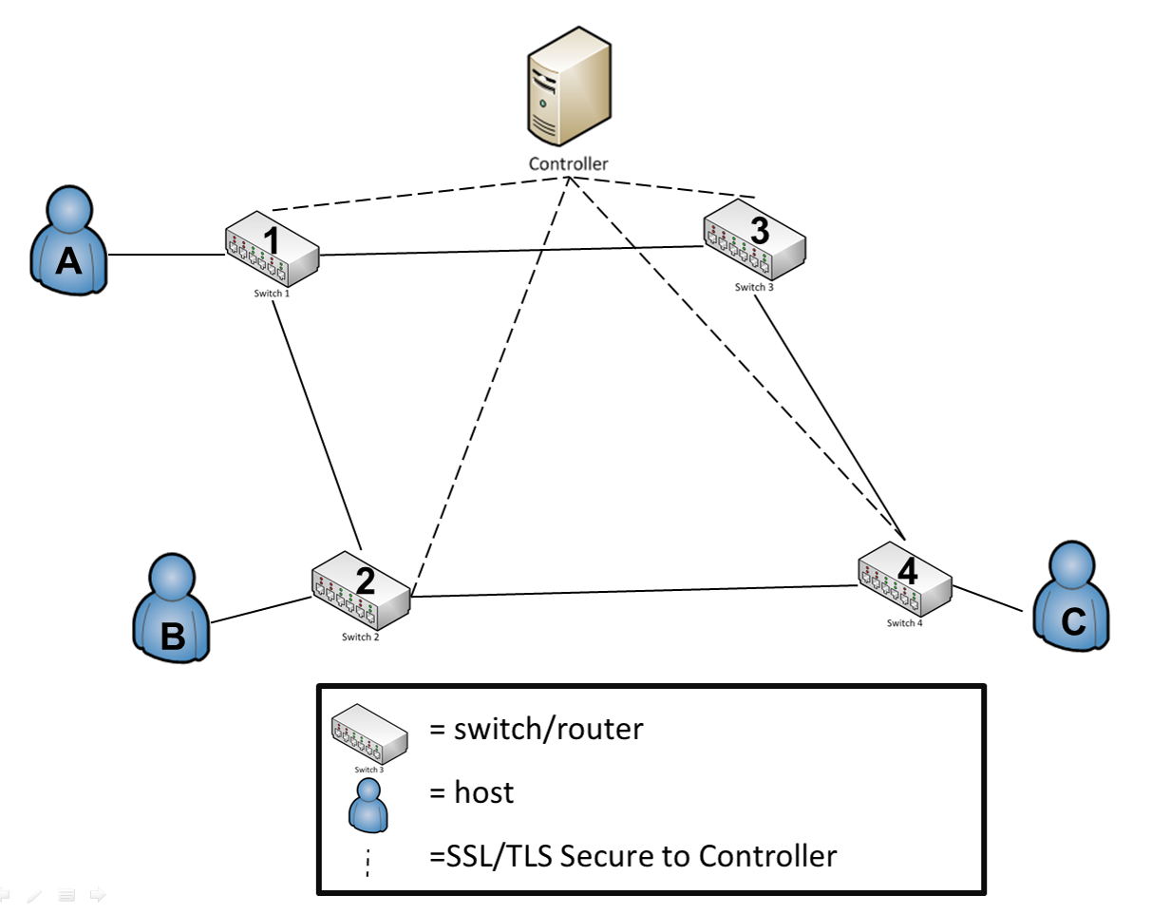
Figure 4: Example SDN Topology

Packet/Flow Size
We could potentially measure the size of the first and last packets, then multiple it by the total number within a flow. Packet size can then be compared as the data flows from switch to switch and from each of the three elements of message traffic (pre/post and actual).
U(P_{x1 +} P_{x2 +} P_{x4)}U , U(P_{y1 +} P_{y2 +} P_{y4)}U , U(P_{x1 +} P_{x2 +} P_{x4)}
(P_{y1 +} P_{y2 +} P_{y4)} (P_{z1 +} P_{z2 +} P_{z4)} (P_{z1 +} P_{z2 +} P_{z4)}

Packet/Flow Lapse Time
The time from when packet arrives a switch until it arrives at the next switch. Measuring the packets arrival at two switches provides metrics that should be validated with performance traceroute to assess speed and detect man in the middle attacks. Currently the OpenFlow 1.3 protocol does not support this metric collection.
T_{Px} = Time Packet Arrives at Switch x
Calculating lapse time will help to identify issues within the network, calculating the lapse time between the switch 1 and switch 4.
(T_{P2} - T_{P1}) + (T_{P4} – T_{P2})

Packet/Flow Duration
The time from the first packet until the flow exits the switch. This is the time it takes a flow from arrival to departure from an individual switch. Knowing flow sizes and types/protocol, we could compare the traffic against performance tests and standardized metrics to assess and create expectations for transport time and routing. Currently the OpenFlow 1.3 protocol does not support this metric collection. Comparing the duration of time a flow spends in the Flow Table may help determine if a high volume of malicious data is traveling utilizing the same flow table entry (i.e. many flows, but few packets).
T_{F1}-T_{P1} = total flow time per a given switch

Hop Count
This is a simple metric and is available conventionally; however, the SDN controller could have a much more accurate estimation of the hop count per recipient. This estimation helps validate the path, eliminate routing to devices well outside of the network/system control, and would have limit overhead. It is important to note that hop count can be changed by the controller/installed Flow Entry Action. Therefore this would likely be a minor contributor to the overall metric analysis.

Switch/Device Location
This refers to the geospatial or at least time zone location of a device. This could be used with varying degrees of trust to assess the strength of a partial route. Some larger level (ISP) or company internal switches would have a higher level of trust versus the open internet. Further, in a close classified/sensitive network the location could have a higher degree of trust. Location data should be largely static, so the overhead of calculating the data and assessing a level of trust from proposed path versus the actual path should be minimal. Location data such as an authorized IP range could identify a switch/network owner, combined with an external entity like IANA or a business IT department.

Switch/Device Characteristics
Knowing the type of switch, level within the LAN/WAN hierarchy, and switch owner could all be utilized to develop an algorithm for trust with the network. Physical vs. virtual switches – typically a physical switch would have a higher degree of trust as it is harder to spoof. OpenFlow does not support switch configuration information like owner/manufacturer. Although this information can be gathered using SNMP. The level within the LAN/WAN hierarchy could be inferred by the controller’s view of the network topology. A sample of device characteristics questions includes:
- Is trusted network? Trusted SDN?
- Company owned device?
- Is the traffic wholly within company controlled LAN/WAN?
- Level of the switch/router within transmission at large (e.g. ISP/backbone devices vs. local WiFi Router)
- Grade/Quality of Device: Compare consumer grade vs. commercial grade
- Physical vs. virtual switch

Sender/Receiver Role Based-Access
Linking Active Directory or RADIUS Server to Controller App/Northbound App, traffic could be validated by message type, access of the users and/or user group, pull in location data of the group and compare routing data. This data could also be held or queued if a user was identified as logged off, so it would not flow to the device until the user was logged in and available to receive it. Allowing for integration with outside data sources into the overall SDN confidence analysis provides diversity to the set of metrics and demonstrates a capability that could be expanded networks for large amounts of outside data (biometrics, two-factor authentication, etc.).

Average of Packets per Flow
Data transmission is a two-way street, so it is equally as important to ensure the safety of the receiving node from malicious attack. Many attacks feature source IP spoofing, which makes the task of tracing the attack’s original source very difficult. A side effect is the generation of flows with a small number of packets. Given that normal traffic usually involves a higher number of packets. If we can determine a median value for this, then we can assess confidence [16].

Median Bytes per Flow
Attack payload size is often very small (for example TCP flooding attacks typically contain packets of ~100 bytes). If we can determine a median value for this, then we can assess confidence [17].
md(n) = Un(F/2) + n((F+1)/2)
2

Growth of Single Flows

Verify how many pair-flows occur in the flow stream during a certain interval. Malicious activity often increases the number of single-flows into the network because they send packets with a fake IP [16].

Packet Timestamp Comparison
By employing timestamping on the first packet of a given flow, we can assess exactly when traffic enters and exits SDN hybrid-network. Based upon experience and/or the pre-/post-traffic packets, we can identify if traffic is flowing at a different rate. Although latency may be the cause of this, any deviation would at a minimum degrade our confidence in the data path. Adan additionally, could potentially hash the packet header and timestamp. Passing this to hash to an authentication server (which knows the header) would to validate the packet based upon the returned timestamp.

SDN CAaaS EVALUATION, EXPERIMENTS, AND USE CASES

SDN CAaaS Evaluation
The duration Gathering network device data and being able to validate the path that a data flow travelled is not the end point for SDN CAaaS. Rather it is the beginning of a greater statistical review of the data collected. Utilizing the CARVER-style methodology, developed by US Special Forces, we provide a method to quantitatively assess the impacts of a given course of action or metric [18].
In the case of SDN Confidence, we propose to measure the above metrics against the following characteristics. This will then provide a weighted value with which we can then apply the metrics scoring against. In effect, we will utilize a double weighted analysis (quality of the metric in general and quality of the specific metric).

Quality of the Metric in General
For assessing the meters/metrics in general, we propose the following criteria:
- S: Spoofability – this measures the ability of the metric in general to be falsified in some manner
- M: Measurability – the degree of exactness that SDN allows for measure (whether subjective or objective metric)
- V: Variability – measures the range of acceptable values that would be considered within bounds for a given metric.
We propose developing a baseline measurement for each of the previously identified metrics (ref. Section 5.3) and creating a weighting standard based upon three groups of input:
(1) a general survey of industry/academic professional for their assessment of SMV for each metric – the sample size of “experts” may vary; however, we aim for 100+ respondents. Below is an example of the SMV matrix that will be provided for assessment. The metric definitions listed above will also be provided. No additional guidance will be offered – in order to ensure standardization across the sample.
(2) the authors’ review of existing security and metering research. The value of this assessment is based upon the authors’ unique understanding of their research; however, it is counter-balance (to avoid bias) with item 1.
(3) as each metric is collected and analyzed, we intended to review and assess the SMV characteristics for the metric. Through repeated experimentation and evaluation, it is possible that our assessment of measurability and variability will differ.
Table 1. SMV Rating Scale
Scoring / Criteria | Spoofability | Measurability | Variability
5 | Very difficult to spoof and/or easily recognized by most | Easily assessed metric with limited network overhead | Very narrow band of acceptable values
4 | Hard to spoof and/or easily recognized by some | Easily assessed with moderate network overhead | Small band of acceptable values
3 | Alterable and/or recognized with some training/effort | Assessable metric | Moderate band of acceptable values
2 | Alterable by many and/or hard to recognize | Hard to assess and may reduce performance due to overhead | Large array of acceptable values within a single band
1 | Easily altered and/or very difficult to recognize | Very difficult to assess metric with considerable overhead | Wide array of acceptable values, potentially in different bands

We will utilize a scoring system of 5, 4, 3, 2, 1 with this approach. For each of the three criteria the lower score, the greater the metrics ability to predictably and objectively provide data into a SDN confidence analysis tool.
For the purpose of example below is example assessment of the 7 of the 12 listed criteria. The table below illustrates a baseline assessment of the metrics using a SMV analysis. These numbers are rough approximation that can be refined based upon future testing, verification of assumptions, and the specific environment of the user.
Table 2. Example of Quality of Metric in General
Quality of the Metric/Meter in General
# | Metric Name | Raw Score | Weight (GQW)
1 | Packet Duration | 5 | 3
2 | Flow Size | 5 | 3
3 | Device Characteristics | 8 | 1

Quality of the Specific Measure
As mentioned above, the generalized metric weighting is then weighted again against the quality of the actual measurement. Quality of actual measurement is again weighted for demonstration purposes as a 3-1. The higher the value, the better the quality of the actual metric. Two examples assessments of specific quality are listed below:
- UDevice CharacteristicU: Although this particular metric will be a compilation of several factors (vendor, trust-level, etc.), each element must be assessed for quality. Simply making an assessment that devices from Cisco are great and device from D-Link are poor is of dubious quality. In general due to the subjective nature of this metric, the quality of the data is expected to be lower than more objective measurements.
- URoute VerificationU: Using the “sandwich” method described above in Section 5.1, we are able to verify the route utilizing three separate verifications: the pre-traffic flow, the actual traffic flow, and the post-traffic flow. Therefore the quality of “verified” route by three independent measurements is high.
Table 3. Example of Quality of Specific Measure
Quality of the Specific Measure
# | Metric Name | Raw Score | Weight (SQW)
1 | Packet Duration | 2 | 3
2 | Flow Size | 3 | 5
3 | Device Characteristics | 1 | 1

Final SDN Confidence Analysis
Merging the weight of both analyses provides a final weighted value to then use in conjunction with the metrics themselves. That said the metrics will not be weighted directly (i.e. packet size * weighting), but rather whether or not the metrics are what is expected. For the purpose of this example we used a simple scoring system of 1-3 for ‘not expected’, ‘partially expected’, ‘expected’ value.
In our example the maximum possible score for SDN Confidence is 75 and the minimum score is 25. Even in this small-scale example, there are 27 possible overall scoring variations. In order to assess what scores within an acceptable range two factors must be assessed: (1) is this actual production network data and (2) what is the sensitivity of the traffic itself.
The results of the SDN Confidence Assessment can then be accessed as a service – CAaaS via a northbound controller API by any network tool or system for route verification and overall security of the data path.
The analysis tool described above is for example purposes only and requires experimentation to refine assumptions prior to being deployed as a fully function northbound SDN service.
Table 4. Example of Final SDN Confidence Assessment
SDN Confidence Assessment (Range)
# | Metric Name | Raw Score | GQW | SQW | Final Score
1 | Packet Duration | 1-3 | 3 | 3 | 9-27
2 | Flow Size | 1-3 | 5 | 3 | 15-45
3 | Device Characteristics | 1-3 | 1 | 1 | 1-3
 |  |  |  | Total | 25-75

Experiments
To better illustrate the assessment process, we developed an application to collect two data points (packet duration and packet size) for analysis. The purpose of this collection and analysis is to provide an example of the CAaaS concept. Future refinement of the assessment baseline, weighting, and testbed is necessary for deliver more meaningful data. All experiments were run under VMware vSphere 5.1 as virtual machines with 4 x 2.66GHz CPUs, 4GB RAM, and 300GB of storage assigned. The network model for this data collection resembles that in Figure 4. Table 5 below shows a sample of the data collect for each metric.
Table 5: Sample of Collected Metrics
UDuration of Event (100ns) | USrc. IP | UDest. IP | UTrans.  U MAC | URec. MAC | UPacket ID | UPacket Length
857230 | <A | B> | <1 | 2> | 122359 | 1070
899044 | <A | B> | <2 | 4> | 122359 | 1070
936830 | <A | B> | <4 | B> | 122359 | 1070

After raw collection the data was analyzed for the standard deviation, s, between each point of collection. The ratio of deviation, n, was then assessed as to whether or not it meet expected values. If the tool does not have historical data to baseline expected values, then an average rating will be assessed. For this example, the first simulation is used to baseline the route and subsequent simulation data is measured against it.
The raw data assessments are then weighted based upon the criteria listed in Sections 6.1.1 and 6.1.2. Similarly the weighted values for this example are those listed in Tables 2 add 3.
To derive a summary path confidence assessment (see Table 7), the average of the final weighted measures for each point of collection are assessed against an acceptable confidence matrix, see Table 6 below. The confidence assessment ranges are provided in Table 8 for example purposes.
Table 6: Packet Duration Confidence Matrix
 | SW (1,2) | SW (2,4) | SW (4,B) | Std. Dev., s: | Total , N | Sum: | Ratio of Dev., | Final Weighted Measure
UPre-Traffic | 934246 | 915933 | 889199 | 22654 | 3 | 2739378 | 120 | 27
UActualTraffic | 857230 | 899044 | 936830 | 39816 | 3 | 2693104 | 67 | 18
UPost-Traffic | 903751 | 895933 | 861739 | 22343 | 3 | 2661423 | 119 | 27

Table 7: Summary Confidence Matrix
Metric / Run | Raw Scoring (1=not expected, 2=partial, 3=as expected) | GQW - table 4 | SQW - table 4 | Final Weighted Measure
Packet Duration | 3 | 3 | 3 | 24
Flow Size | 3 | 5 | 3 | 45
Device Characteristics | 3 | 1 | 1 | 3
 |  |  | Sum | 72
 |  |  | Mean | 24
 |  |  | Confidence Assessment | High

Table 8: Confidence Assessment Range
Confidence Assessment
Highest | >98% | >26.46
High | 88-98% | 23.76-26.46
Moderate | 60-88% | 16.2-23.76
Low | <60% | <16.2

To further enhance the assessment individual points of data collection could be compared against prior simulations (a baseline for the data flow) in order to provide a confidence assessment for each device in each simulation.

Use Cases

Verify Route Using Duration Metric
The duration metric for each flow is the elapsed time since the flow was created. We use this metric to verify that each flow entry for a flow has not been changed since it was created. For simplification a new flow can be created for data transfer, but an existing flow can also be used if the flow ID is known. The route source address is inferred from the ingress device in SDN.
Input: destination address, caller address
Output: flow ID, creationTime, durationTable, routeVerifiedFlag
1. The caller starts the verification process by sending the authentication server (CAaaS) a request to establish a route supplying a destination address. Source address can be inferred since the ingress point for verification must be the edge of the SDN network. The CAaaS then establishes a route using the SDN controller for that network and notes the time it was created and the flow ID. The CAaaS then returns the FlowId to the caller.
2. The caller then transfers the data over the flow using the flow ID.
3. The caller then requests verification from the CAaaS using the creation time and flow ID.
4. The CAaaS then gets the route from the controller using the flow ID.
5. Each switch in the route is then polled for the duration (time since creation) of that flow using the switch identifier and flow ID.
6. If each duration matches the creation time then the flow entry has not changed and a true verified flag is returned.
7. If any switch duration is different from the creation time, a false verified flag is returned with a table listing each switch ID and duration for analysis by the caller.
Note: The caller can use an existing flow for repeat operations. The creation time of the existing flow switches will be gathered. If the creation times are all the same, then this flow can be reused. If not, then a new flow will be created and flow ID returned.

Validate Route Using SDN Traceroute
This service is designed to validate an existing route. The route is comprised of forwarding hardware (in this case, switches) that is known to the SDN controller. Using the device IDs (pulled from the controller), flow rules for the probe packet are installed on the switches. A probe packet is then sent to the destination address. SDN Traceroute maps the actual route that the probe packets took across the forwarding plane using the actual flow rules installed on the switch. Each switch sends the probe back to the controller for logging. The route is recorded until the packet reaches the destination switch.
The CAaaS then compares the actual route to the route that the SDN controller has defined. If the controller route is equal to the actual route, then this route can be said to have been validated.
Input: call takes a destination address, takes or infers source address
Output: flow ID, boolean routeValidated
1. Caller starts the validation process by supplying a destination address or a flow ID.
2. CAaaS then performs the SDN Traceroute.
3. Actual route is compared to what the controller has.
4. If the routes match then a routeValidated true is returned, false if not. The two routes are also returned for analysis by the caller

CONCLUSION AND FUTURE WORK
A serious problem when passing message traffic is getting the data to the right person, place, time, location, and route. CAaaS provides a framework which can verify the path meets set standards, validates the actual route that the message travels and assesses network metrics to reassure the user confidence in the overall transport process. We have laid the groundwork to provide a service that can be polled by an outside authentication/key exchange service to help ensure the quality of the data transmission. Future work will include implementing this service and providing finer grained look into the real-world weighting structure and analysis. Additionally, we hope to explore endpoint security, traffic whitelisting, and capitalizing on our tracing a pushback/traceback ability for attack defense.

ACKNOWLEDGMENTS
First and foremost, we want to thank our families for their encouragement and support. Without them none of this would be possible. And for their continued interest in our research, we wish to thank the leadership of the College of Engineering and Applied Sciences at UCCS and Northrup Grumman.

REFERENCES
- Godfrey, P. B., Ganichev, I., Shenker, S., and Stoica, I. Pathlet Routing. In Proceedings of the ACM SIGCOMM, 2009.
- Zhang, H., et al. Enabling Layer 2 Pathlet Tracing through Context Encoding in Software-Defined Networking. In Proceedings of HotSDN ’14, 2014.
- Agarwal, K., Rozner, E., Dixon, C., and Carter, J. SDN Traceroute: Tracing SDN Forwarding Without Changing Network Behavior. In Proceedings of the Third Workshop on Hot Topics in Software Defined Networking, 2014.
- Naous, J., Walfish, M., Nicolosi A., Mazières, D., Miller, M., and Seehra, A. Verifying and Enforcing Network Paths with Icing. In Proceedings of the Seventh Conference on Emerging Networking Experiments and Technologies, 2011.
- Way, A. Alan Talks Tech. 19TUhttp://alantestwiki.pbworks.com/UT.
- T. Sheldon. Packets and Packet Processing Networks. http://en.wikipedia.org/wiki/Packet_processing#Data_plane/.
- Enterprise Networking Planet. The OpenFlow Revolution is a Big Switch. http://www.enterprisenetworkingplanet.com/netsp/the-OpenFlow-revolution-is-a-big-switch.html/.
- Stace Hipperson’s Blog. Visualising OpenFlow/SDN - Big Switch Floodlight Controller Data in Hyperglance. http://www.stacehipperson.com/blog/2012/11/3/visualising-OpenFlowsdn-big-switch-floodlight-controller-in-hyperglance/.
- Duffy, J. Early OpenFlow User Details ‘Exciting’ Benefits. http://www.networkworld.com/article/2180216/ethernet-switch/early-OpenFlow-user-details--exciting--benefits.html/.
- Guis, I. Things to Consider For Your SDN Strategy : OpenFlow. http://www.sdneasy.com/things-to-consider-for-your-sdn-strategy-OpenFlowx/. [Accessed: 13-Aug-2013].
- Network Computing. SDN Is Business, OpenFlow Is Technology. http://www.networkcomputing.com/next-gen-network-tech-center/sdn-is-business-OpenFlow-is-technology/240142193/.
- OpenvSwitch. http://openvswitch.org/.
- The Killer App for OpenFlow and SDN – Security. http://www.rationalsurvivability.com/blog/2011/10/the-killer-app-for-OpenFlow-and-sdn-security/.
- Clayton, R. The Limits of Traceability. 2001.
- OpenFlow. OpenFlow Specification. http://www.opennetworking.org/sdn-resources/.
- Braga, R., Mota, E., and Passito, A. Lightweight DDoS flooding attack detection using NOX/OpenFlow. In IEEE 35th Conference on Local Computer Networks, 2010.
- Guo, R., Yin, H., Wang, D., and Zhang, B. Research on the Active DDoS Filtering Algorithm Based on IP Flow. In International Journal of Communications, Network and System Sciences, 2009.
- Bennett, Brian T. Understanding, Assessing, and Responding to Terrorism: Protecting Critical Infrastructure and Personnel, 2007.

